The below is from 3 sources. Two by Denninger cited in a Rumanian one.

Thursday, September 10. 2009
Posted by Karl Denninger in Consumer at 13:19

The Consumer Credit Game Is OVER
We recently got an updated G.19 from The Fed that contained "revised" consumer credit numbers that showed the top in consumer credit (all but mortgages) was in fact in July of 2008, not January of 09 as previously reported.
This morning the US Census released its update with per-capita income numbers for 2008 being released.
Here's the updated "big picture" chart - click for a bigger copy, and please note that I have updated the file repository, so Tickers from the previous couple of weeks that used this "benchmark" chart will update as well.
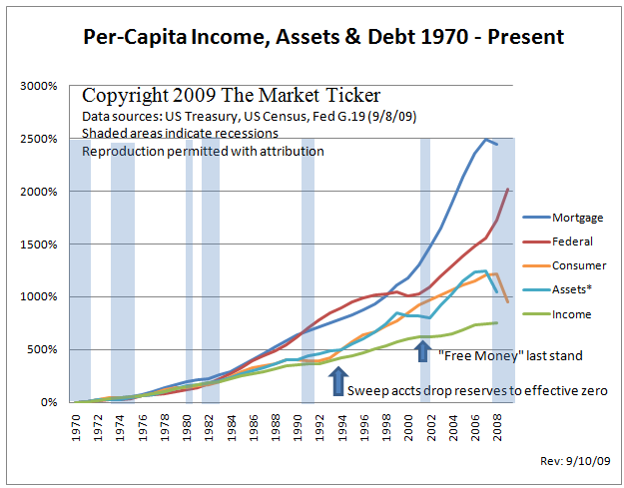
* Chart note: The Federal Debt and Consumer credit numbers are updated as of 9/10/09; all other figures are as of 12/2008 as 2009 numbers are not yet available in comparable formats.
Let me be crystal-clear so nobody can say later they weren't warned: If any part of your economic thesis going forward requires that consumer borrowing expand in order to foster economic growth you are wrong and everything you believe that depends on that is also wrong. Further, any belief that per-capita income has not SHRUNK from the flat-lined 2006-2008 levels in 2009 is also wrong, although the Census numbers for 2009 will not be out until September 2010.
This chart shows you clearly what happened and why we cannot simply borrow our way out of the box - despite unprecedented decreases in Fed Funds [rates] and unprecedented "liquidity programs" all of mortgages, consumer credit and household assets either flat-lined or fell dramatically while at the same time there has been effectively no growth in per-capita income.
In other words we hit the wall even through the cost and availability of funds received unprecedented "support" from both the government and Federal Reserve.
There is no more borrowing capacity among consumers as a group. Contraction of this magnitude and rate-of-change is NOT occurring by choice; consumers are being forced to either pay down or default debt they cannot afford to carry. It is no longer possible to expand outstanding consumer credit - that is, we cannot "pull forward demand" any longer, as the consumer's per-capita income, even with short-term interest rates at ZERO, is insufficient to support further credit issuance.
The Greenspan gambit to avoid a "Kondratiev Winter" has failed.
Mr. Greenspan is said to have once remarked during the 00-03 market implosion that this was indeed exactly what he was trying to prevent, strongly implying that he was well-aware of where we were in the credit cycle (that is, he had the up-to-2000 version of the above chart and understood it) and that should he fail the results would be catastrophic.
I cannot verify that conversation took place (and I've tried), but it does make sense - after all, Greenspan may be many things, but stupid isn't one of them.
We have continued to pretend that the above graph does not represent reality. We have shifted borrowing from citizens to the Federal Government in a (futile) attempt to keep the credit-expansion game going. It can't and won't work - the evidence is, at this point, irrefutable that what I laid forth as our destiny in 2007, like it or not, is occurring.
The character of what was attempted in 2000 is obvious from this chart: Boost borrowing against homes and by the government. When the home borrowing scheme failed and started to self-destruct The Federal Government has attempted to pick up that piece as well, a trend that is clear starting in 2007 and has continued since.
There is no way out of the box via this method; we are in fact headed for a sovereign credit, monetary system and thus GOVERNMENT failure if we don't stop! WE MUST accept a contraction to sustainable levels of economic activity and STOP trying to substitute for consumer demand with government borrowing or we WILL witness the collapse of our governing funding model when those who loan the government money realize that the US consumer is INCAPABLE of resuming their former credit-expansionist way of life.
Do not be fooled by the talking heads on TV - the above graph proves what is really going on and what is at stake. It is not possible to "restart" credit demand among consumers as we have failed in our efforts to boost consumer income, the means by which one pays debt. The consumer has hit the wall as ever-increasing demands on income for the necessities of life - the price of which (food, fuel and medical care in particular) has risen much faster than their income and they are trapped.
At the same time the claims of "lower interest rates make it easier to pay debt" have been proved false. Interest rates on consumer debt have gone up, not down, as banks have effectively stolen the lower short-term funding rates to paper over and hide their losses while raising interest rates on consumer borrowing. At the same time the housing bubble was formed during a time when long-term borrowing rates for consumers (mortgages) were at or near all-time lows, and as a consequence there has been no meaningful relief there either - nor can there be.
Finally, the insane ramp in Federal Borrowing has resulted in a precipitous decline in the value of the dollar - a decline that is now threatening to become disorderly.
In other words, policy actions have had and will have no impact on the group that must recover for a durable economic recovery - the consumer - as those lower borrowing costs either can't be or haven't been passed through but instead are being STOLEN to cover up bank insolvencies and are CAUSING upward pressure in the price of necessities.
Nobody in the "mainstream media" is talking about this chart but it is in fact the key to literally everything. The market has been on a tear since March precisely because the banks have been able to cover up their insolvency and are gambling with that Federal "put" to them but in doing so they have further damaged the consumer's balance sheet. Not only have interest rates spiked higher on consumer revolving credit (credit cards) but in addition the banks have plowed money into commodities (oil in particular) doubling its price over the last few months and putting a further twist on the thumbscrew of consumer budgets via gasoline prices!
This is now showing up in the outstanding credit numbers - the consumer's balance sheet and health is deteriorating fast as consumers simply are unable to afford their existing debts, say much less taking on any new ones. There is zero evidence of stabilization in this regard, irrespective of Geithner's claims to the contrary.
Ignore the above graph at your own considerable peril.

The following is from Green Shoots? WHERE IS GLOBAL TRADE?
…………….
………………
The bottom line is right here folks:
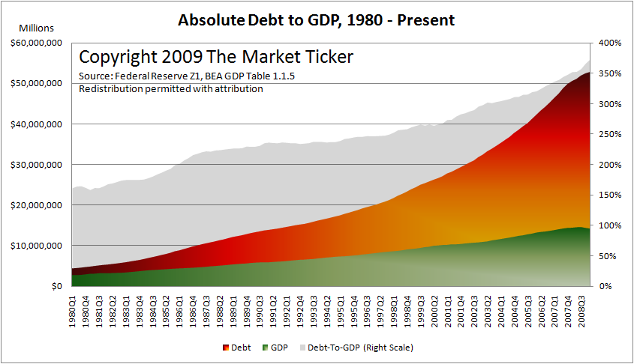
This cannot be sustained. It simply cannot. I don't care if people want it to be, I don't care if bankers want it to be, it does not matter.
At a ratio of 375% of debt to GDP with an interest rate of just five percent the nation expends $2.65 trillion in interest costs, or about 20% of GDP.
That's $2.65 trillion dollars that does not go to salaries of productive workers, it does not go toward inventing new machines and technologies, and it does not help advance the common weal of The United States.
That interest rate, by the way, is likely to be impossibly low. Remember that included in there is not just the manipulated short-term rate for credit to the Federal Government; indeed, most credit is not Federal. It is private in some form or fashion, whether charged to consumers for credit card use, to companies for inventory and expansion, or to investors and speculators who wish to deploy capital in the markets in a leveraged format.

………………….
…………………..

The law of exponential growth cannot be repealed, and it is impossible for an exponential growth process to continue forever in any venue where there is a hard, physical boundary on the maximum expansion possible.
We live in such a venue. It is called the Planet Earth and it has a finite size, surface area, and carrying capacity for people. While we can (and have) expanded that carrying capacity through the exploitation of technology it is nonetheless finite and eventually must and will succumb to the pressure placed on our economic system by the abusive nature of exponential growth mandates.
We appear to have hit that wall when it comes to debt, just as we did in the 1920s, resulting in The Great Depression.
The Depression was not caused, as Bernanke and others have (knowingly falsely) claimed, by a "failure" of The Fed to appropriately loosen monetary policy.
The Depression was caused by the more than decade-long expansion of credit in exponential fashion - a mathematical impossibility to sustain. That expansion in turn led to a demand for the consumption of ever-more of output in the form of interest payments. When those payments exceeded the ability of persons and corporations to pay the system collapsed, as defaults cascaded through the system causing unemployment, slack capacity and thus more defaults.
The premise of being able to "halt the damage" through the issuance of more credit is in fact a Ponzi Scheme. It is mathematically impossible to do anything more than delay the taking of damage and by doing so the ultimate loss is made worse. The very definition of a Ponzi Scheme - that is, the taking of money (credit) from new "investors" (citizens) to pay off the claims of the old, is exactly what was done in 2001 and is being done now.
Such frauds are supposed to be illegal under the general context of a fraudulent transaction: That is, the making of a promise that is mathematically impossible over an extended period of time.
Why is not Ben Bernanke, along with the remainder of the Fed Governors and every public official who has made such a statement under oath before Congress (including Tim Geithner) not now under indictment?

